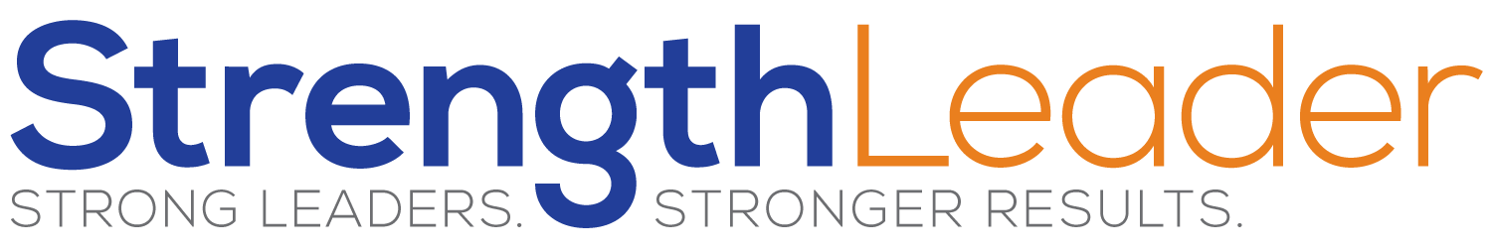

My Best

Strengths That Resonate With Me From My Assessment:

Others Have Said I’m Good At:

Common Action Words From My 10 Stories:

I engaged Successfully With:

Time Flies When I Am:

Satisfaction Comes From:

