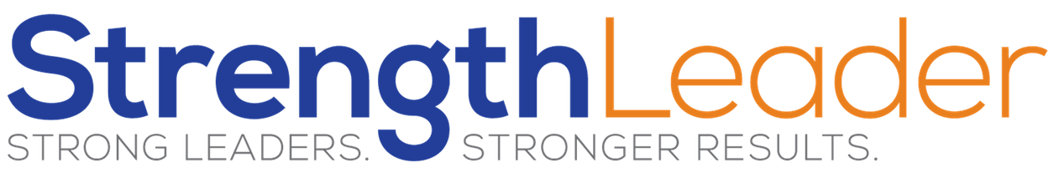

Lead With Your Strengths…Optimized

 | Not Likely | Neutral | Likely
Strengths Zone
Ideal Environment
Motivation
Lifestyle
Income
Wealth

