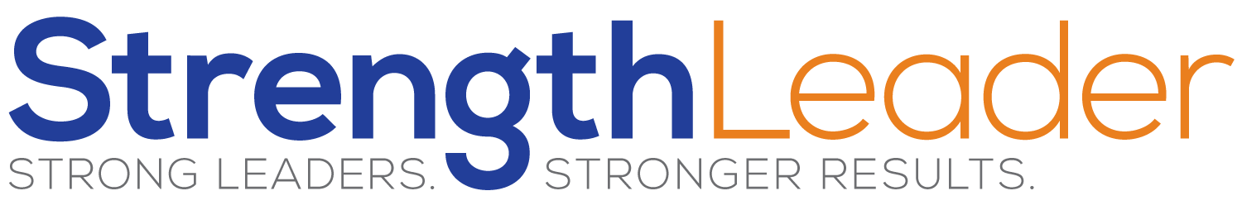

50 Ideas
List fifty ways you can use the key elements from your ‘Discovering MY BEST’ Worksheet. Don’t prejudge whether or not you can earn money doing it, there are experts who can help with monetizing ideas, but rather just ensure its using one or more of your strengths, your Best Actions, in a way that would help you to feel ‘satisfaction’ in the activity, and would keep you interested.
The key with these activities is to be sure it uses one of your key Strengths and would give you satisfaction.
1
2
3
4
5
6
7
8
9
10
11
12
13
14
15
16
17
18
19
20
21
22
23
24
25
26
27
28
29
30
31
32
33
34
35
36
37
38
39
40
41
42
43
44
45
46
47
48
49
50

FAQ
I can’t come up with 50 what should I do?
Sure you can, you may think some of the ideas stink, but you can do it. Don’t be embarrassed by anything on the list, I had Eulogy writer on mine!
I have a hard time being creative, I’m not a creative thinker I’m more logical what should I do?
That is great because regardless of whether you are a right brainer or left brainer the only critical piece is whether or not you use the MY BEST activity sheet
If it is something I haven’t done yet, how do I know if I will find it satisfying or not?
Use your best judgment but sometimes as you sift though your ideas, you mind find a topic from one, executed with an idea from another.
My ideas are all the same, I can’t get creative!
Write the down anyway and if you feel it is too heavy in one direction and you are concerned, increase your list to 75 or 80.
I know what I want to do, why do I need to make the list?
If you know what you want to do that is great, but be careful to ensure your idea is using the items listed in the MY BEST worksheet.
I’m listing things I’ve already done only, is that right?
Nope, you want to list things you’ve done, as well as things you have not done but have seen others do.
Ok I’ve got my list of 50 but I don’t like any of them what do I do?
That leads right to our next step...read below.
Next up... We’ll take you through our Decision Optimizer so you can filter the ideas worthy of your pursuit.

